Rutgers Business School

33:136:370 Management Information Systems

Instructor: Disha Parkhi

SQL Queries - Introduction

SQL is a standardized computer language that was originally developed by IBM for querying, altering and defining relational databases, using declarative statements. These notes cover the essentials of querying a database with SQL.
Queries in SQL are made with a SELECT statement that starts with the clause SELECT. The SELECT statement is constituted by the following clauses in the following order:
(Required:) SELECT (optional:) DISTINCT (Optional:)
(Required:) FROM
(Optional:) WHERE
(Optional:) GROUP BY
(Optional:) HAVING
(Optional:) ORDER BY
(Required:) ; (semicolon to end the statement)

We will use the Employee table as an example. The Employee table has the following columns:
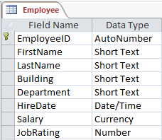
The simplest query would be:
SELECT <column_names>
FROM <table_name>;
For example:
SELECT *
FROM Employee;
This simple example gets all the data in the table Employee (all columns and rows). The wildcard “*” is used when you want to get all the columns in the table(s) in FROM.
If you only want some of the columns, you specify the names of the columns you want:
SELECT EmployeeID, LastName, FirstName
FROM Employee;
Note: SQL clauses are not case sensitive. SELECT is the same as select. Also, you can break your code in multiple lines or have everything on the same line.
The default syntax for specifying a column is TableName.ColumnName; but we can skip TableName for those columns that have unique names within the tables called in FROM. Column names or table names that contain spaces must be enclosed in square brackets, for example Orders.[Product Ordered].
In SELECT you can also make calculations using columns, called calculation fields. For example, in SELECT you could write "Quantity*UnitPrice", and it multiplies the Quantity and UnitPrice fields to make make a new table column with the result. This new column can be given a name by writing "AS name" after the expression (see “3. The AS Clause”).

1. The WHERE Clause
The WHERE clause is used to extract only those records that fulfill a specified criterion. The syntax is as follows:
SELECT columns
FROM tables
WHERE logical_conditions;
Example:
SELECT *
FROM Employee
WHERE Salary >= 50000;
The logical conditions in WHERE are comparisons (like "=" or "<=") that can be combined using logical operations (like AND and OR), and parentheses.
Logical Conditions Operators
Operator | Description | Logical condition examples
= | Equal | FirstName = “John”
<> | Not equal | Department <> “Marketing”
>, <, >=, <= | Inequalities | Salary >= 100,000; HireDate < #01/01/2015#
BETWEEN … AND … | Between an inclusive range | HireDate BETWEEN #01/01/2017# AND #12/31/2017#
IN(..….. ) | Checks if a field is in a list of values | Building IN (“North”, “South”, “Main”)
IS NULL | Checks if a field is empty | Building IS NULL
LIKE | Search for a pattern.  * - The star sign represents zero, one, or multiple characters  ? - The question mark represents a single character  Note: Usually, SQL in other software use the symbol ‘%’ instead of ‘*’, and symbol ‘_’ instead of ‘?’. | LastName LIKE ‘J*’ | Finds all last names starting with a ‘J’.
LIKE |  | LastName LIKE ‘*a’ | Finds all last names ending with a ‘J’.
LIKE |  | LastName LIKE ‘*th*’ | Finds all last names containing syllable ‘th’ anywhere.
LIKE |  | EmployeeID LIKE 3? | Finds all EmployeeID values with two digits that start with 3.
LIKE |  | EmployeeID LIKE 3?3 | Finds all EmployeeID values with three digits that start with 3 and end up with 3.

In logical conditions, SQL uses single or double quotes around text values, as shown in the examples above and, in Ms Access, cardinal symbol (#) around dates.

Combining logical conditions with the AND, OR, NOT Operators
The AND operator displays a record if both the first condition and the second condition is true.
The query:
SELECT *
FROM Employee
WHERE LastName='Smith' AND FirstName='John';
would give:
The OR operator displays a record if either the first condition or the second condition is true. The query:
SELECT *
FROM Employee
WHERE LastName='Smith' OR FirstName='John';
would give:
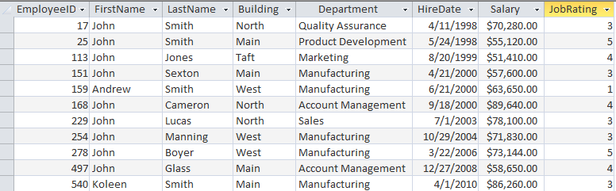
You can also combine AND and OR (use parenthesis to form complex expressions). Example:

SELECT *

FROM Employee
WHERE LastName='Smith' AND (FirstName='John' OR FirstName='Koleen');
Which would result in:
Finally, NOT is used to negate a logical condition. E.g.

WHERE NOT Salary >= 50000
is the same as
WHERE Salary < 50000.
Two examples of using NOT:
WHERE NOT (LastName='Smith' AND FirstName='John'),
Which would retrieve everybody whose name is not John Smith;
WHERE NOT Department IN (“Marketing”, “Sales”),
Which would retrieve everybody in all departments except Marketing and Sales.

2. Sorting rows: ORDER BY
If you want the data to appear in a specific order you need to use the “order by” clause. In front of ORDER BY usually follows a list of columns. After each field (and before the following comma if there is one), you can put ASC for ascending (alphabetically or smallest to largest) order, or DESC for descending order (backwards or largest to smallest). If you don't put either, SQL assumes ascending order. You can use calculated fields too and/or aggregate functions.
The precedence of sorting is left-to-right as the fields are listed. That is, "ORDER BY LastName, FirstName" will order first by LastName, and then, within each set of records with the same LastName, it will order by FirstName.

3. Aliases: the AS clause
Aliases are optional but often useful. You can give a table in FROM or a column in SELECT another name by using an alias. This can be a good thing when you have very long or complex table names or column names. An alias name could be anything, but usually it is short.
A single table can appear several times in FROM. In this case, each occurrence must be given a unique name by its tables name with "AS alias". Even if a table shows only once in FROM we can also use aliases to make the query easy to write.

SQL Alias Syntax for Tables:

FROM table1 AS alias_name1, table2 AS alias_name2, …
Table aliases can be used elsewhere in the query.

SQL Alias Syntax for Columns:

SELECT column_name AS alias_name, calculated_field AS calc_name, …
Aliases in SELECT only affect the final view of the query and cannot be used anywhere in the query.

4. Removing duplicates: SELECT DISTINCT
After a query, some of the rows may contain duplicate values. If you want to remove the duplicate rows, you use SELECT DISTINCT. Example:
SELECT DISTINCT FirstName FROM Employee;
This query goes to table Employee and selects the column FirstName. Since there are multiple employees with the same FirstName it would retrieve all the repeated names unless we use DISTINCT.

